Darshan Kalpeshbhai Prajapati

112908215

Lab5

ANS1;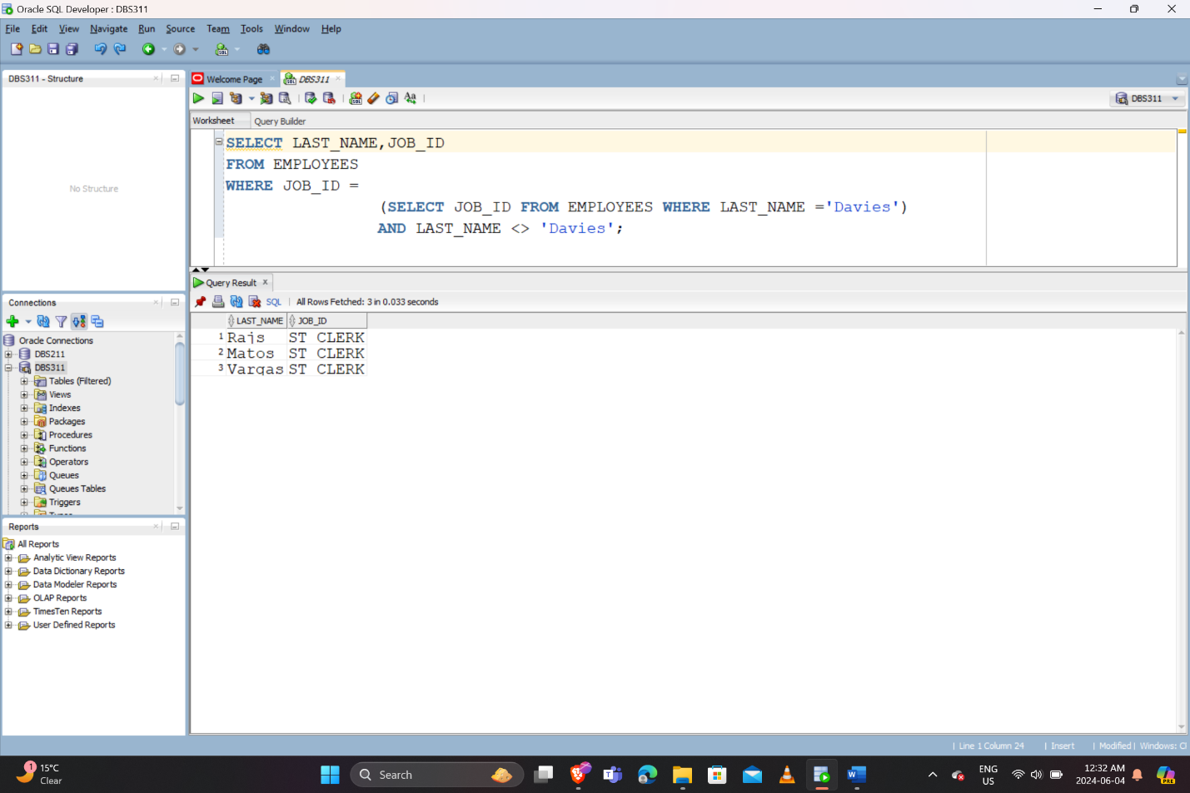

ANS2:

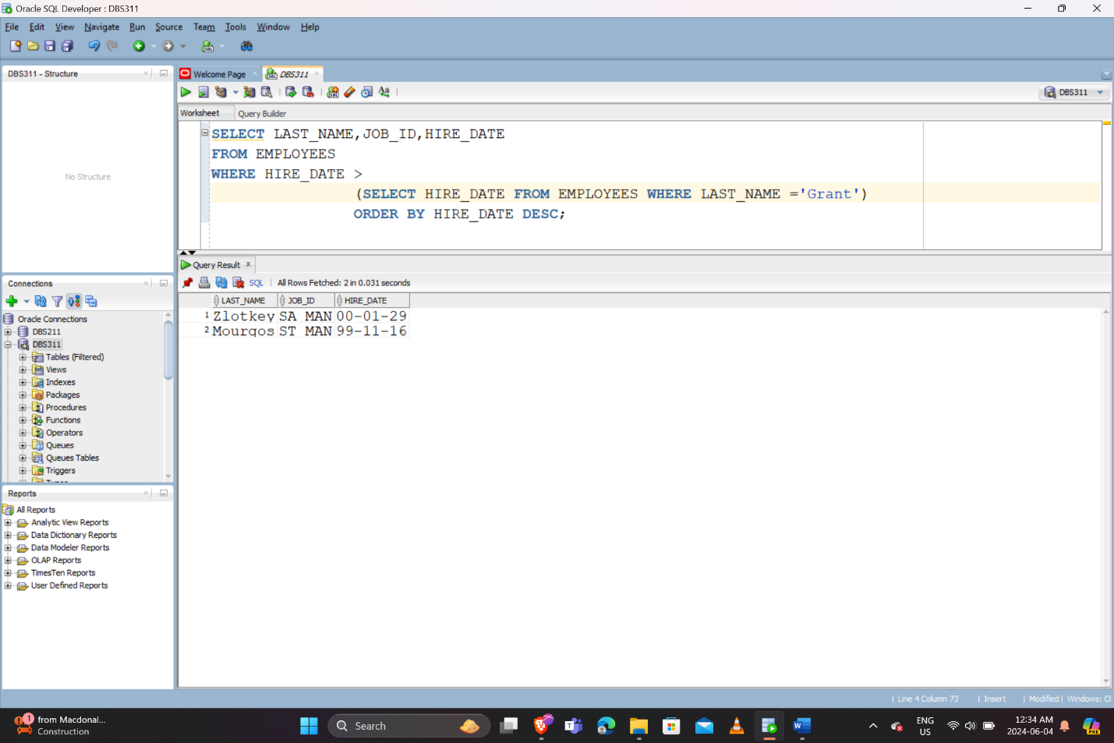

ANS3:

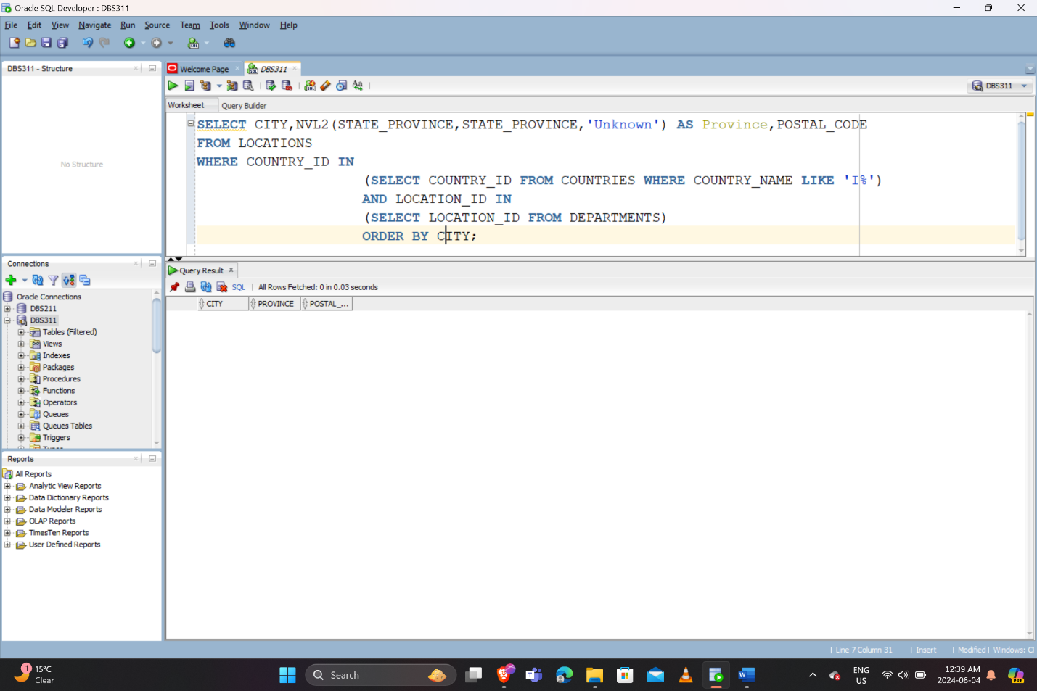

ANS4:

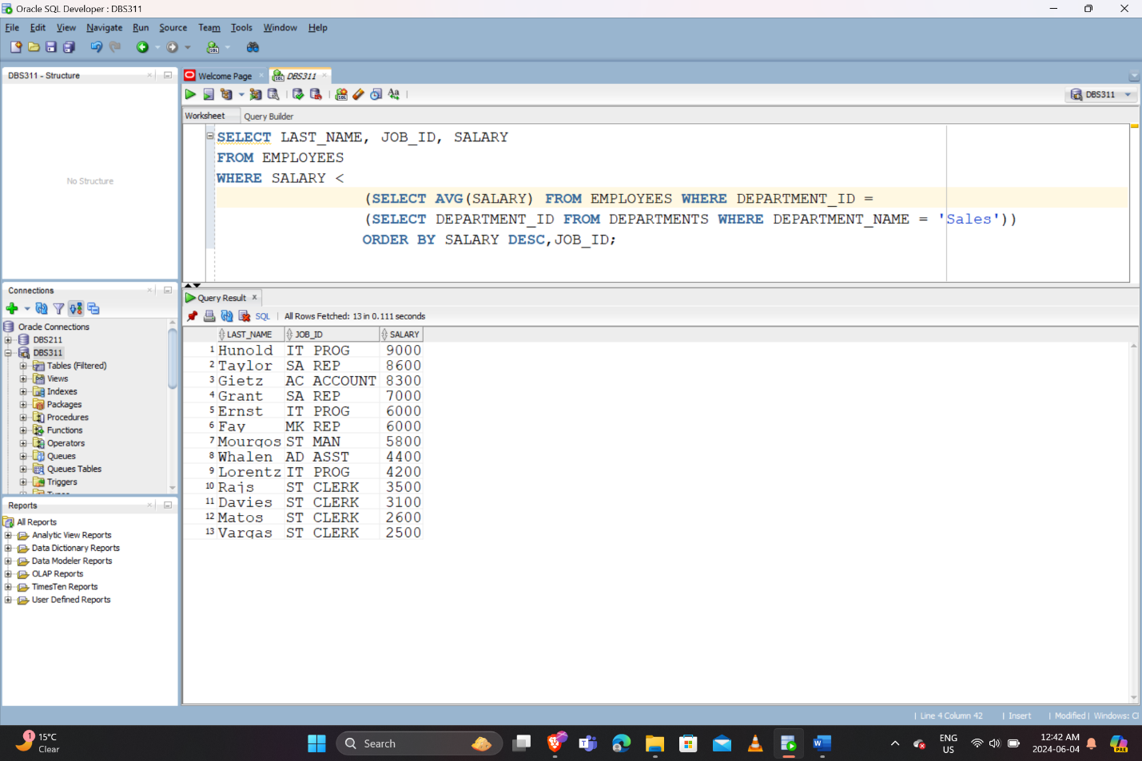

ANS5:

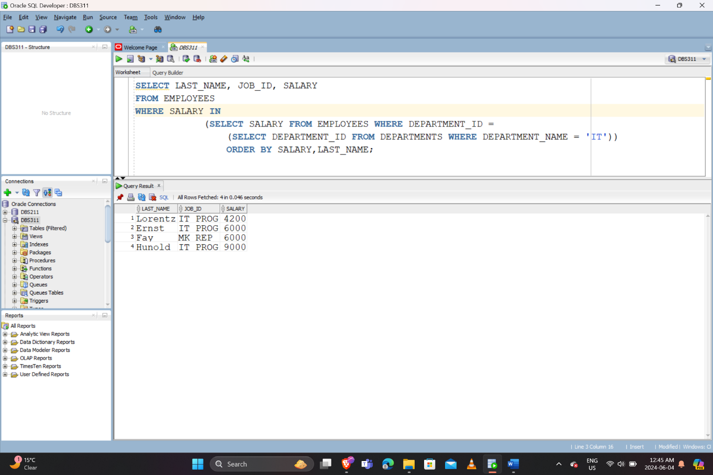

ANS6:

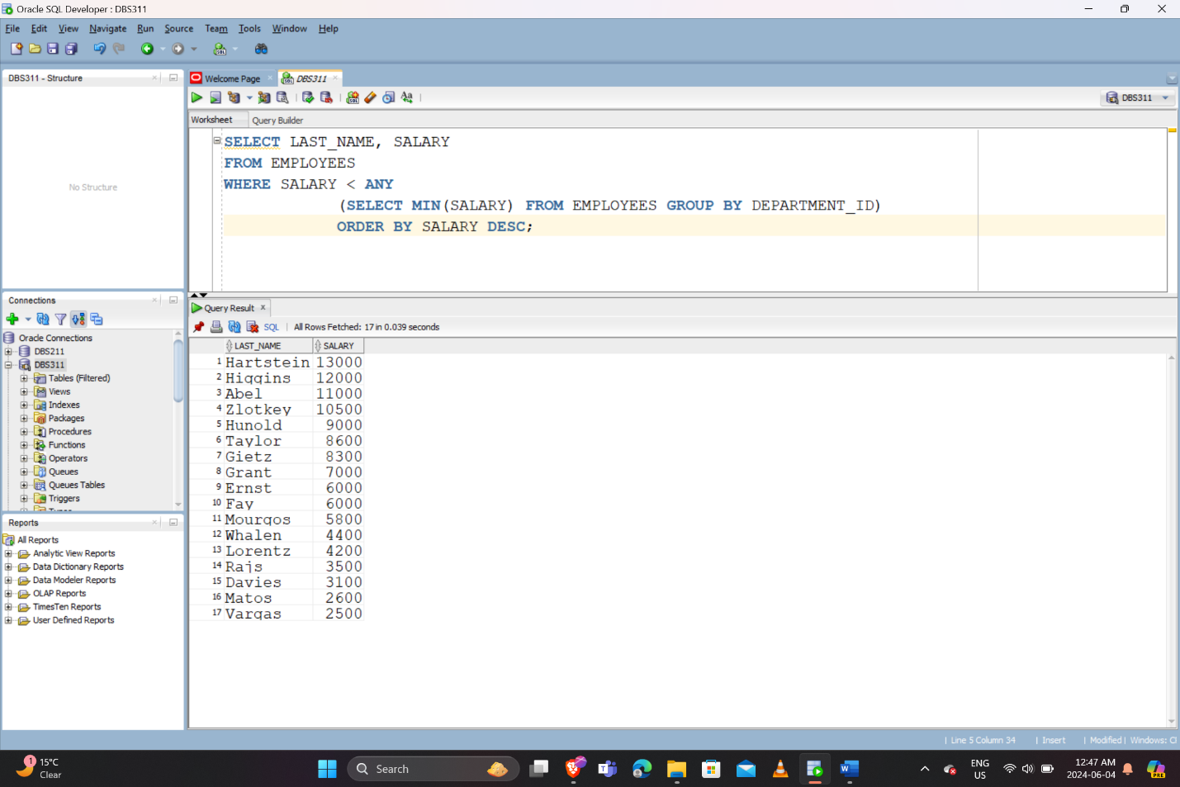

ANS7:

THERE ARE TOTAL 6 DUPLICATE ROWS AND TO MODIFY STATEMENT I CAN WRITE UNION INSTEAD OF UNION ALL TO REMOVE DUPLICATE ROWS.

ANS8:

SELECT manager_id, department_id

FROM employees

INTERSECT

SELECT manager_id, department_id

FROM departments;

ANS9:

MINUS OPERATOR IS USED WHEN YOU WANT TO KNOW WHAT IS UNIQUE IN FIRST QUERY’S RESULTS.BASICALLY IT SUBTRACTS THE RSULTS OF THE SECOND QUERY FROM THE RESULTS OF THE FIRST QUERY.